Network In Network V2

0. Environment

|  |  |
| --- | --- |
| DataSet | CIFAR-10 |
| Language | Python3.5 & Tensorflow 1.0 |
| optimizer | Adam |
| Loss function | Cross entropy Loss |

Input : 32x32x3 size image

1. initialize

|  |  |
| --- | --- |
| layer | 3x3 conv (filter = 64, pad) |
| output | 32x32x64 |

2. module (10 times)

|  |  |
| --- | --- |
| Layer | 3x3 conv (filter = 64, pad) |
| output | 32x32x64 |
| Layer | 1x1 conv (filter = 64) |
| output | 32x32x64 |
| Layer | relu |
| output | 32x32x64 |
| Layer | 1x1 conv (filter = 64) |
| output | 32x32x64 |
| Layer | relu |
| output | 32x32x64 |

3.Average_pool

|  |  |
| --- | --- |
| layer | 1x1 conv (filter = 10) |
| output | 32x32x10 |
| layer | 32x32 average_pool |
| output | 10 |

4. Overall

|  |  |
| --- | --- |
| Training(7600 iteration) | Time : 21352.2598195076 seconds |
| Accuracy : 0.567 |
| Validation | Accuracy : 0.553 |
| Re-training(64 iteration) | Accuracy : 0.585 |
| Re-Validation | Accuracy : 0.553 |
| Test | Acurracy : 0.574 |

Training

Iteration 0: with minibatch training loss = 2.36 and accuracy of 0.094

Iteration 100: with minibatch training loss = 1.99 and accuracy of 0.25

Iteration 200: with minibatch training loss = 1.99 and accuracy of 0.2

Iteration 300: with minibatch training loss = 2.15 and accuracy of 0.27

Iteration 400: with minibatch training loss = 1.95 and accuracy of 0.28

Iteration 500: with minibatch training loss = 1.93 and accuracy of 0.2

Iteration 600: with minibatch training loss = 1.8 and accuracy of 0.27

Iteration 700: with minibatch training loss = 1.79 and accuracy of 0.3

Epoch 1, Overall loss = 1.99 and accuracy of 0.214

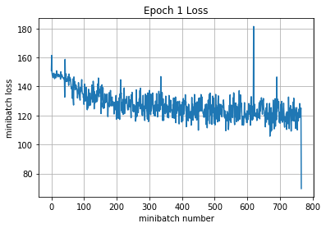

Iteration 800: with minibatch training loss = 1.74 and accuracy of 0.25

Iteration 900: with minibatch training loss = 1.86 and accuracy of 0.28

Iteration 1000: with minibatch training loss = 1.8 and accuracy of 0.42

Iteration 1100: with minibatch training loss = 1.68 and accuracy of 0.34

Iteration 1200: with minibatch training loss = 1.68 and accuracy of 0.41

Iteration 1300: with minibatch training loss = 1.58 and accuracy of 0.39

Iteration 1400: with minibatch training loss = 1.6 and accuracy of 0.31

Iteration 1500: with minibatch training loss = 1.41 and accuracy of 0.48

Epoch 2, Overall loss = 1.73 and accuracy of 0.328

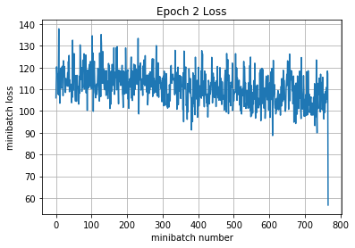

Iteration 1600: with minibatch training loss = 1.74 and accuracy of 0.3

Iteration 1700: with minibatch training loss = 1.75 and accuracy of 0.38

Iteration 1800: with minibatch training loss = 1.57 and accuracy of 0.36

Iteration 1900: with minibatch training loss = 1.48 and accuracy of 0.38

Iteration 2000: with minibatch training loss = 1.58 and accuracy of 0.38

Iteration 2100: with minibatch training loss = 1.41 and accuracy of 0.48

Iteration 2200: with minibatch training loss = 1.82 and accuracy of 0.36

Epoch 3, Overall loss = 1.57 and accuracy of 0.408

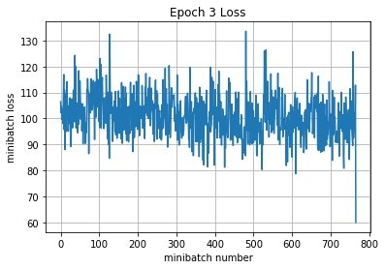

Iteration 2300: with minibatch training loss = 1.57 and accuracy of 0.39

Iteration 2400: with minibatch training loss = 1.65 and accuracy of 0.34

Iteration 2500: with minibatch training loss = 1.56 and accuracy of 0.42

Iteration 2600: with minibatch training loss = 1.6 and accuracy of 0.42

Iteration 2700: with minibatch training loss = 1.34 and accuracy of 0.52

Iteration 2800: with minibatch training loss = 1.53 and accuracy of 0.38

Iteration 2900: with minibatch training loss = 1.41 and accuracy of 0.45

Iteration 3000: with minibatch training loss = 1.37 and accuracy of 0.47

Epoch 4, Overall loss = 1.45 and accuracy of 0.458

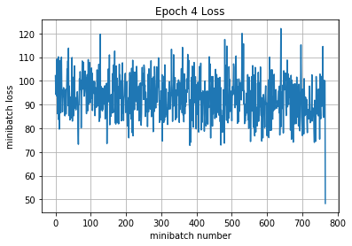

Iteration 3100: with minibatch training loss = 1.35 and accuracy of 0.53

Iteration 3200: with minibatch training loss = 1.27 and accuracy of 0.55

Iteration 3300: with minibatch training loss = 1.35 and accuracy of 0.53

Iteration 3400: with minibatch training loss = 1.49 and accuracy of 0.45

Iteration 3500: with minibatch training loss = 1.56 and accuracy of 0.45

Iteration 3600: with minibatch training loss = 1.27 and accuracy of 0.55

Iteration 3700: with minibatch training loss = 1.19 and accuracy of 0.55

Iteration 3800: with minibatch training loss = 1.29 and accuracy of 0.48

Epoch 5, Overall loss = 1.38 and accuracy of 0.488

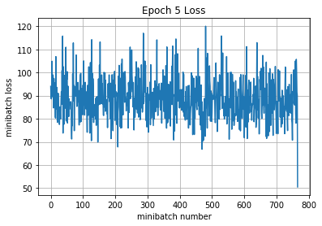

Iteration 3900: with minibatch training loss = 1.59 and accuracy of 0.48

Iteration 4000: with minibatch training loss = 1.5 and accuracy of 0.48

Iteration 4100: with minibatch training loss = 1.41 and accuracy of 0.48

Iteration 4200: with minibatch training loss = 1.35 and accuracy of 0.53

Iteration 4300: with minibatch training loss = 1.11 and accuracy of 0.64

Iteration 4400: with minibatch training loss = 1.24 and accuracy of 0.61

Iteration 4500: with minibatch training loss = 1.47 and accuracy of 0.5

Epoch 6, Overall loss = 1.33 and accuracy of 0.512

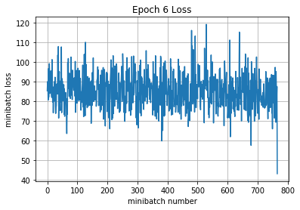

Iteration 4600: with minibatch training loss = 1.42 and accuracy of 0.53

Iteration 4700: with minibatch training loss = 1.3 and accuracy of 0.5

Iteration 4800: with minibatch training loss = 1.13 and accuracy of 0.53

Iteration 4900: with minibatch training loss = 1.27 and accuracy of 0.5

Iteration 5000: with minibatch training loss = 1.37 and accuracy of 0.44

Iteration 5100: with minibatch training loss = 1.19 and accuracy of 0.59

Iteration 5200: with minibatch training loss = 1.34 and accuracy of 0.53

Iteration 5300: with minibatch training loss = 1.05 and accuracy of 0.61

Epoch 7, Overall loss = 1.28 and accuracy of 0.532

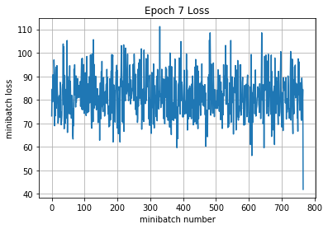

Iteration 5400: with minibatch training loss = 1 and accuracy of 0.61

Iteration 5500: with minibatch training loss = 1.29 and accuracy of 0.53

Iteration 5600: with minibatch training loss = 1.26 and accuracy of 0.59

Iteration 5700: with minibatch training loss = 1.28 and accuracy of 0.55

Iteration 5800: with minibatch training loss = 1.51 and accuracy of 0.47

Iteration 5900: with minibatch training loss = 0.955 and accuracy of 0.67

Iteration 6000: with minibatch training loss = 1.4 and accuracy of 0.5

Iteration 6100: with minibatch training loss = 1.29 and accuracy of 0.53

Epoch 8, Overall loss = 1.24 and accuracy of 0.548

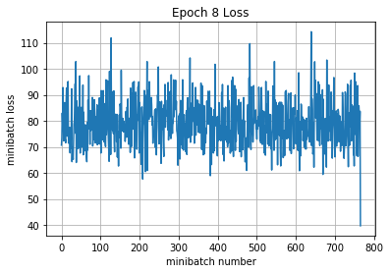

Iteration 6200: with minibatch training loss = 1.29 and accuracy of 0.55

Iteration 6300: with minibatch training loss = 1.16 and accuracy of 0.59

Iteration 6400: with minibatch training loss = 1.2 and accuracy of 0.58

Iteration 6500: with minibatch training loss = 1.22 and accuracy of 0.56

Iteration 6600: with minibatch training loss = 1.09 and accuracy of 0.58

Iteration 6700: with minibatch training loss = 1.11 and accuracy of 0.61

Iteration 6800: with minibatch training loss = 1.01 and accuracy of 0.67

Epoch 9, Overall loss = 1.21 and accuracy of 0.559

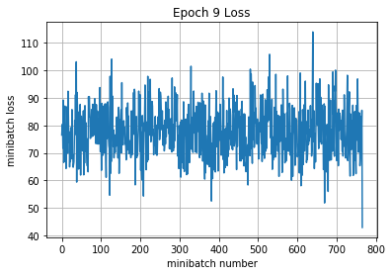

Iteration 6900: with minibatch training loss = 1.01 and accuracy of 0.62

Iteration 7000: with minibatch training loss = 1.41 and accuracy of 0.5

Iteration 7100: with minibatch training loss = 1.23 and accuracy of 0.53

Iteration 7200: with minibatch training loss = 1.01 and accuracy of 0.62

Iteration 7300: with minibatch training loss = 1.13 and accuracy of 0.56

Iteration 7400: with minibatch training loss = 1.51 and accuracy of 0.48

Iteration 7500: with minibatch training loss = 1.14 and accuracy of 0.61

Iteration 7600: with minibatch training loss = 1.27 and accuracy of 0.56

Epoch 10, Overall loss = 1.19 and accuracy of 0.567

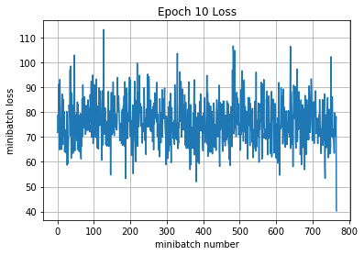

21352.2598195076

Validation

Epoch 1, Overall loss = 1.23 and accuracy of 0.553

Training

Epoch 1, Overall loss = 1.15 and accuracy of 0.585

Validation

Epoch 1, Overall loss = 1.23 and accuracy of 0.553

Test

Epoch 1, Overall loss = 1.18 and accuracy of 0.574